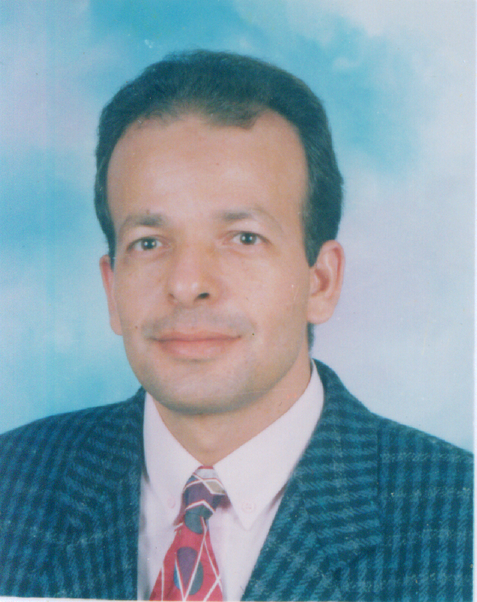
CRICULUM VITAE
NAME: Prof. Dr. Nassr-Allah H. Abdel-Hameid
BIRTH DATE: September /21/ 1965
CONTACT:
-e-mail: nassr65@gmail.com
-Tel: 0020246166360
-Mobile: 00201009013817
-Fax: 0020133222578
Web site: http://bu.edu.eg/staff/nasrallahabdelmagid7
GRADUATIONS:
-B.Sc. of Zoology at 1987, Zagazig University, Benha Branch, Egypt.
-M.Sc of Zoology at 1994, Zagazig University, Benha Branch, Egypt.
-Ph.D. of Zoology at 1998, Zagazig University, Benha Branch, Egypt.
OCCUPATIONS:
-Demonstrator at Zoology Department, faculty of Science, Zagazig University, Benha Branch, Egypt ( Since August 1987).
-Assistant lecturer at Zoology Department, faculty of Science, Zagazig University, Benha Branch, Egypt (Since June1994).
-Lecturer of Zoology, Department of Zoology, faculty of Science, Benha University, Egypt (Since November1998 till July 2007).
-Associate prof of Zoology, Department of Zoology, faculty of Science, Benha University, Egypt (Since July 2007 till June 2013).
- Professor of fish biology, Department of Zoology, faculty of Science, Benha University, Egypt (Since June 2013 till now).

POST DOC FELLOWSHIP:
-Post doc fellowship for six months at Oklahoma state university and Oregon state university, USA (2000-2001).
- INSA-JRD TATA Post Doc fellowship for three months at Aligarh Muslim University, India (7/10/2008 -7/1/2009).
-HSB Post Doc Scholarship hosted at University of Pannonia from 01 October 2009 to 03 June 2010, Hungary.

CONFERENCES:
1- Attending the 2 ^{nd} International conference “The theme of Environmental Science & Technology" which is held at National Research Centre Cairo, Egypt 4-6/9/ 2006.
2- Attending The Arabian Seas International Conference on Science and Technology of Aquaculture, Fisheries and Oceanography, State of Kuwait, 10-13/2/2007.
3- Attending the ³² conference of the ethological society “National Symposium on Fish behavior” which held at central Institute of Fisheries Education, Mumbai, India (16-17 October 2008).
4-Attending the conference of the Asian Fisheries Society (Indian Branch) under topic Fish for health and livelihood, which is held at Kolakta, India ( form 22-26 November 2008).
5-Presenting posture in the VII conference on macroinnvertebrates (Sümeg, Hungary 2010. április 15-16-17) (VII. Makroszkopikus Vízi Gerinctelenek Kutatási Konferencia Sümeg, 2010. április 15-16-17 ) Hungary.
6. Attending and presenting two papers in the 9th annual international conference of the society of experimental biology held at Cairo University conference center, Egypt (23-27 February 2013).
7-Attending the conference on Agricultural development of Sinai, organized by the Agricultural and biological research division, National Research Center, Egypt, 10-11 December 2012.

RESEARCH ACTIVITIES:
My research activities were focused on the study of ecotoxicology, reproductive physiology, haematology, and histology and protein electrophoresis of fish species under experimental and field observations. Also, I study the physiology of maturation of fish species.

REFEREES
- Prof Dr. Sabry El-Serafy, prof of fish biology, University of Benha, Benha, Egypt, e mail: sabry_elserafy2000@yahoo.com.
- Prof Dr. Nóra Kováts, prof of ecotoxicology, Department of Limnology, University of Pannonia, Egyetem u. 10., P.O.B. 158, 8200, Veszprém, Hungary, e mail: kovats@almos.uni-pannon.hu.
- Prof Dr. Mukhtar Khan, Prof of fish nutrition, Department of Zoology, Aligarh Muslim university, Aligarh, UP, India, e mail: khanmukhtar@yahoo.com.
- Prof Dr. M. N. Nagy, prof of animal physiology and dean faculty of Science, University of Benha, Egypt, e mail: M.Nagy_54@hotmail.com.

LIST OF PUBLICATIONS:
1- Nassr-Allah H. Abdel-Hameid (2007). Protective role of dimethyl diphenyl bicarboxylate (DDB) against erythromycin induced hepatotoxicity in male rats. Toxicology in Vitro Toxicology in Vitro, 21(4), 618-625.
2-Sabry S. El-Serafy, Nassr-Allah H. Abdel-Hameid, Mohammed H. Awwad and Mona S. Azab (2007). DNA riboprinting analysis of Tilapia species and their hybrids using restriction fragment length polymorphisms (RFLPs) of the small subunit ribosomal DNA. Aquaculture Research, 38, 295-303.
3-El-Serafy S. S., Awwad M.H., Abdel–Hameid N. A. H. and Azab M. S. (2003). Restriction fragment length polymorphisms (RFLPs) of the small subunit ribosomal DNA as a tool for identification of Tilapia spp. Egypt. J. Aquat. Biol. & Fish., 4: 465-482.
4- Sabry S. El-Serafy; Nassr-Allah H. Abdel-Hameid; Mohammed H. Awwad and Mona S. Azab (2006). Comparative study on electrophoretic protein pattern of Tilapia species in the river Nile, Egypt. Proceedings of the 7th International Symposium on Tilapia in Aquaculture, Arizona, USA, 281-292.

5- Sharaf –Eldeen, K. and Abdel-Hameid, N. (2002): Sublethal effects of copper sulphate, Malathion and Paraquat on protein pattern of Oreochromis niloticus. Egypt. J. Aquat. Biol. & Fish., 6 (2): 167-182.
6- Nassr-Allah H. Abdel-Hameid (2007). Physiological and histpathological changes induced by phenol exposure in Oreochromis aureus juveniles. Turkish Journal of fisheries and Aquatic Sciences, 7: 131-138.
.
7- Abdel-Halime , M. E.; Mossad, M. N. M. and Abdel-Hameid, N. ( 1999). Effect of hormonal injection and temperature on some blood parameters of the Nile tilapia. Zagazig University Medical journal, VI (3), 83-94.
8- Emam, O. A. and Abdel-Hameid, N.(2001). Effect of food processing on heavy metal bioaccumulation in fish flesh of Oreochromis niloticus. Journal of Home Economics- Minoufiya University, 11 (2), 1-15.

9- Nassr-Allah H. Abdel-Hameid (2009). A protective effect of calcium carbonate against arsenic toxicity on the Nile catfish, Clarias gariepinus. Turkish Journal of fisheries and Aquatic Sciences, 9(2): 191-200.

10- Sabry S. El-Serafy, Nassr-Allah H. Abdel-Hameid and Amal A. El-Daly (2009). Histological and Histochemical Alterations Induced by Phenol Exposure in Oreochromis aureus (Steindachner, 1864) Juveniles. Egyptian Journal of aquatic biology and fisheries 13 (2), 151- 172.
11. Amal A. El-Daly and Nassr-Allah H. Abdel-Hameid (2009). Architectural disturbances in the testis of the blue tilapia (Oreochromis aureus) juveniles exposed to phenol. Egyptian Journal of Aquatic Biology and Fisheries. 13 (4): 433-445.
12- Mohamed El-Hady and Nassr-Allah H. Abdel-Hameid (2009). Histopathological alterations on the liver of Northern plains killifish (Fundulus kansae, Garman 1895) induced by exposure to pesticides (Terbufos and Atrazine). Egypt. J. Exp. Biol. (Zool.), 5: 273-278.
13- Kováts Nóra , Nassr-Allah Abdel-Hameid, Ács András, Kárpáti Árpád és Paulovits Gábor (2010). Assessing ecotoxicity of municipal wastewater on Pseudanodonta complanata glochidia. Accepted for publication in Zoological Communications - official journal of the Hungarian Academy of Sciences, Hungary (In Magyar Language with English summary).
14- Abdel-Hameid N. H.; Kovács N.; Kováts K.; Ács A. and Paulovits G. (2010). Toxicitási tesztek Alalmazása Hazi Kagylófajokra. "Ecotoxicological testing on native bivalve species". Presented as posture in "VII. Makroszkopikus Vízi Gerinctelenek Kutatási Konferencia Sümeg, 2010. April 15-16-17" the VII Macroscopic Aquatic Invertebrates Research Conference, Sümeg, Hungary 2010. április 15-16-17. Acta Biologica Debrecina Oecologica Hungaica 21: 9-14 ((In Magyar Language with English summary).
15- N. Kováts, N. Abdel-Hameid, K. Kovács, G. Paulovits (2010)
Sensitivity of three unionid glochidia to elevated levels of copper, zinc and lead. Knowledge and Management of Aquatic Ecosystems, an international journal on freshwater ecosystem, 399, 04.
16- Nassr -Allah Abdel-Hameid (2011). Effect of starving and feeding on some haematological and physiological responses of the Nile catfish, Clarias gariepinus exposed to copper at extreme seasons. Fish physiology and biochemistry, 37, 4: 875-884 (DOI 10.1007/s10695-011-9485-0).
17- Kata Kovács, Géza B. Selmeczy, Tamás Kucerka, Nassr-Allah H. Abdel-Hameid, Judit Padisák (2011). The effect of stream bed morphology on Shredder abundance and leaf-litter decomposition in Hungarian midland streams. Polish Journal of Environmental Studies, 20 (6): 1547-1556.

18-Nassr -Allah Abdel-Hameid, S.F. Abidi and Mukhtar A. Khan (2012). Dietary vitamin E requirement for maximizing the growth, conversion efficiency, biochemical composition and haematological status of fingerling Channa punctatus. Aquaculture Research, 43 (2): 226-238.
19- A. Kovács, N.-A. Abdel-Hameid, A. Ács, Á. Ferincz, N. Kováts (2012). A novel protocol for assessing aquatic pollution, based on the feeding inhibition of Daphnia magna. Knowledge and Management of Aquatic Ecosystems, 404, 07. (DOI: 10.1051/kmae/2012001).
20-Kováts N; Abdel-Hameid N-A; Kováts K; Padisák J (2012) Evaluation of single and interactive toxicities of lead and iron using filtration rate of Zebra mussels (Dreissena polymorpha). In: Bebbia CE; Chon T-S (2012) Environmental impact: 577-588 , WIT Press, Southampton ISBN 978-1-84564-604-2.
21- S. S. El-Serafy, M.E. Zowail, N. H. Abdel-Hameid, M. H. Awwad, and E. H. Omar (2013). Effect of dietborne metals on body indices of Nile tilapia (Oreochromis niloticus) with emphasis on protein pattern. Egypt. J. Exp. Biol. (Zool.), 9(1): 15-24.
22- Sabry S. El-Serafy, Nassr-Allah H. Abdel-Hameid, Hany A. Abdel-Salam, Walaa M. Shaalan (2013). Effect of feed colours on growth, feed utilization and biochemical parameters of blue tilapia (Oreochromis aureus, Steindachner, 1864). Egypt. J. Exp. Biol. (Zool.), 9(1): 25 – 32.
.23. E.M. Embaby, Nahed, M. Ayaat, N. H Abd El-Hameid, Mona M. Abdel-Galil, A.A. Yaseen and Marwa, A. Younos (2012). Detection of Fungi and Mycotoxin Affected Wheat Quality. Journal of Applied Sciences Research8 (7):3382-3392.

-

